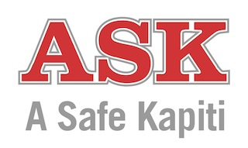
“A safe, crime-free Kapiti”

Social Services Team
Referral Form

Child’s Name:………………………………………………… D.O.B: ……………
Gender: F M (please circle) Age: …… years ……. (months)
Ethnicity: ……………………………… Iwi: …………………………..
Address: ……………………………………………………………………………………………..

Parent/Guardian Name/s: (1) …………………………….. (2)………………………………
Parent/Guardian (1) Daytime contact no:………………………Mobile:…………………..
Parent/Guardian (2) Daytime contact no:………………………Mobile:……………………

School:…………………………Year/Class…………………Teacher:……………………………

Concerns leading to this referral:
- ………………………………………………………………………………………
- ………………………………………………………………………………………
- ………………………………………………………………………………………

Have these concerns been discussed with the whanau/family? Yes / No
Is the whanau/family aware this referral has been made? Yes / No
Are any other agencies involved? Yes / No
If yes please list agencies and contact person if known

* If there is any immediate danger to the child or care and protection issues, contact Oranga Tamariki ( 0508 326 459 ) or the Police 111.

Referrer name………………………………… Position: ………………………………
Contact Phone: ………………………………. Email ……………………………………
Signed:……………………………………………………….. Date: ………………………
PRIVACY STATEMENT
The Privacy Act 2020 applies to any personal information collected by A Safe Kapiti (ASK).

ASK will collect and validate a client’s information for the purpose of engagement in a referral process following them providing the details as is required in the consent form. If information cannot be validated ASK will ask the client for clarification.

ASK will be open and transparent with all clients regarding information held on them. A client has the right to request access to that information and correct that information if required.

ASK will not collect any personably identifiable information other than is required for the puropose of the referral process. However, client files can be viewed by an MSD assessor on-site to evidence compliance with accreditation standards.

Any personal information collected will be managed by ASK in accordance to the principles of the Privacy Act 2020.

